MAHARASHTRA STATE BOARD OF TECHNICAL EDUCATION,
MUMBAI
Shri Vishweshwar Shikshan Prasarak Mandal’s
Vishweshwarayya Abhiyantriki Padvika Mahavidyalaya,
Almala

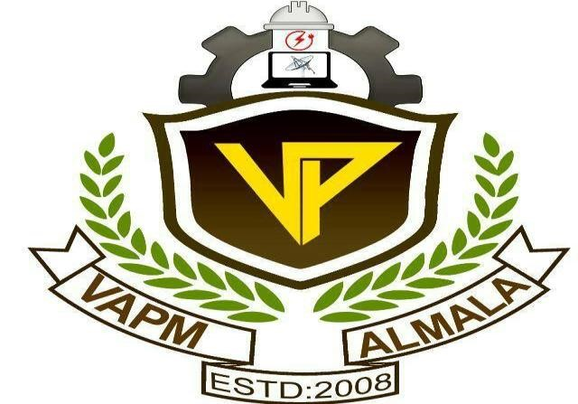

Certificate
This is to certify that, Mr. Omanand Prashant Swami, Mr. Amay Nitin Devshatwar and Mr. Somesh Mahadev Bharbade students of our institute from Second year Computer Engineering (CO3I) have/has successfully completed the micro project report on “Develop a Program in ‘C’ that Creates Tree to Store Given Data Set using Linked List Representation. Locate & Display a Specific Data From The Data Set” of course “Data Structures Using ‘C’ (22317)” as part of curriculum by the Maharashtra State Board of Technical Education , Mumbai.
For partial fulfillment of “Diploma in Computer Engineering” during the academic year 2022-23.

GUIDE HOD
Mr. Chavan A.Y Mr. Lokare A.P

PRINCIPAL
Mr. Dharashive P.S

MAHARASHTRA STATE BOARD OF TECHNICAL EDUCATION,
MUMBAI
Shri Vishweshwar Shikshan Prasarak Mandal’s
Vishweshwarayya Abhiyantriki Padvika Mahavidyalaya,
Almala.
Micro-Project Report On
“Develop a Program in ‘C’ that Creates Tree to Store Given Data Set using Linked List Representation. Locate & Display a Specific Data from The Data Set ”
Submitted By

Enrollment No Name of Student
2110950050 Mr.Omanand Prashant Swami
2110950088 Mr.Amay Nitin Devshatwar
2110950103 Mr.Somesh Mahadev Bharbade

Under the Guidance of
Mr. Chavan A.Y

Department of Computer Engineering
Academic Year-2022-23

